Notes on Antarctic drainage basins and ACEAS

Several different definitions of drainage basins are available. The major ones are:

Mouginot, J., B. Scheuchl, and E. Rignot. (2017). MEaSUREs Antarctic Boundaries for IPY 2007-2009 from Satellite Radar, Version 2 [Data Set]. Boulder, Colorado USA. NASA National Snow and Ice Data Center Distributed Active Archive Center. https://doi.org/10.5067/AXE4121732AD. Date Accessed 11-13-2022. These have previously been described as the ‘Rignot basins’.

Zwally, H. Jay, Mario B. Giovinetto, Matthew A. Beckley, and Jack L. Saba, 2012, Antarctic and Greenland Drainage Systems, GSFC Cryospheric Sciences Laboratory, at http://icesat4.gsfc.nasa.gov/cryo_data/ant_grn_drainage_systems.php

Other basins exist in the literature, such as Sasgen et al. 2010 or older and more simplified versions of Mouginot et al 2017 (as used by Rignot et al. 2011).

The Mouginot et al and Zwally et al basins are used in IMBIE, with the Mouginot et al. definitions now the primary dataset.

ACEAS approach
To enable collaboration and easy exchange of data within ACEAS, researchers should use the same boundaries wherever possible.
Where data resolution allows, ACEAS research should work with the Mouginot et al. basins as they contain the greatest fidelity and they are generated with modern geodetic datasets. If lower resolution is only possible (such as is often the case with GRACE for instance), then the Zwally et al. dataset should be used. Other datasets should only be used in exceptional circumstances.
Data may be obtained at the links above.

Tools
QGIS/ESRI
Mouginot shape files can be loaded directly into these GIS packages. Both Mouginot (MEASURES) and Zwally (Goddard) basins are provided in the quantarctica package under glaciology.
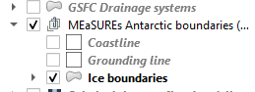

Matlab
Matlab tools for working with these boundaries have been provided by Greene et al. 2017.
Greene, C. A., Gwyther, D. E., & Blankenship, D. D. Antarctic Mapping Tools for Matlab. Computers & Geosciences. 104 (2017) pp.151-157. doi:10.1016/j.cageo.2016.08.003
https://au.mathworks.com/matlabcentral/fileexchange/60246-antarctic-boundaries-grounding-line-and-masks-from-insar

GMT
Shapefiles (.shp) available in the above links may be converted to GMT format by either
ogr2ogr -f "OGR_GMT" Coastline_Antarctica_v02.gmt Coastline_Antarctica_v02.shp [requires GDAL package]

OR

Use QGIS. Right click on the shapefile in QGIS and then Save As -> Format "Generic Mapping Tools [GMT]". Use WGS84 as the CRS, give a file name and click OK.

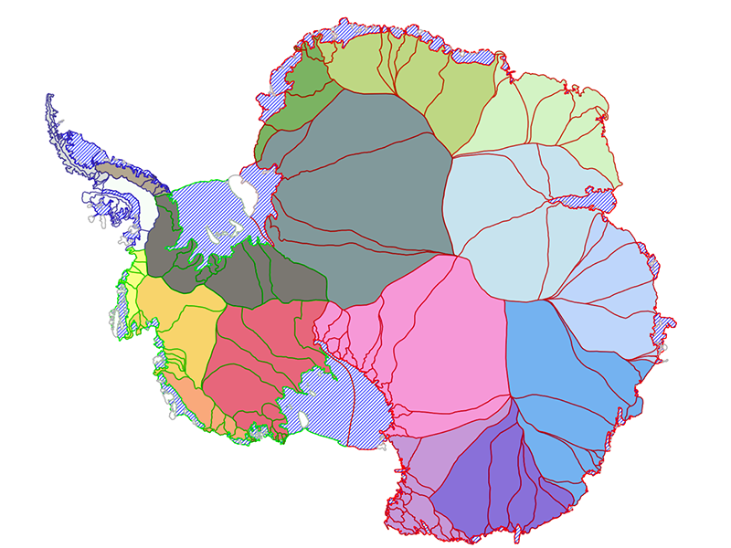
Figure 1: Mouginot et al. 2017 basins
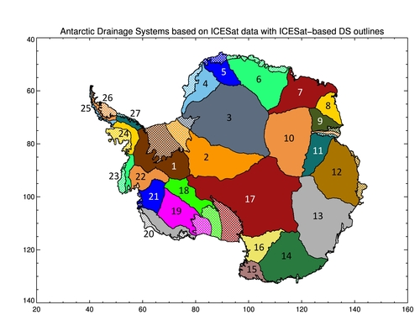
Figure 2: Zwally et al. 2012 basins

