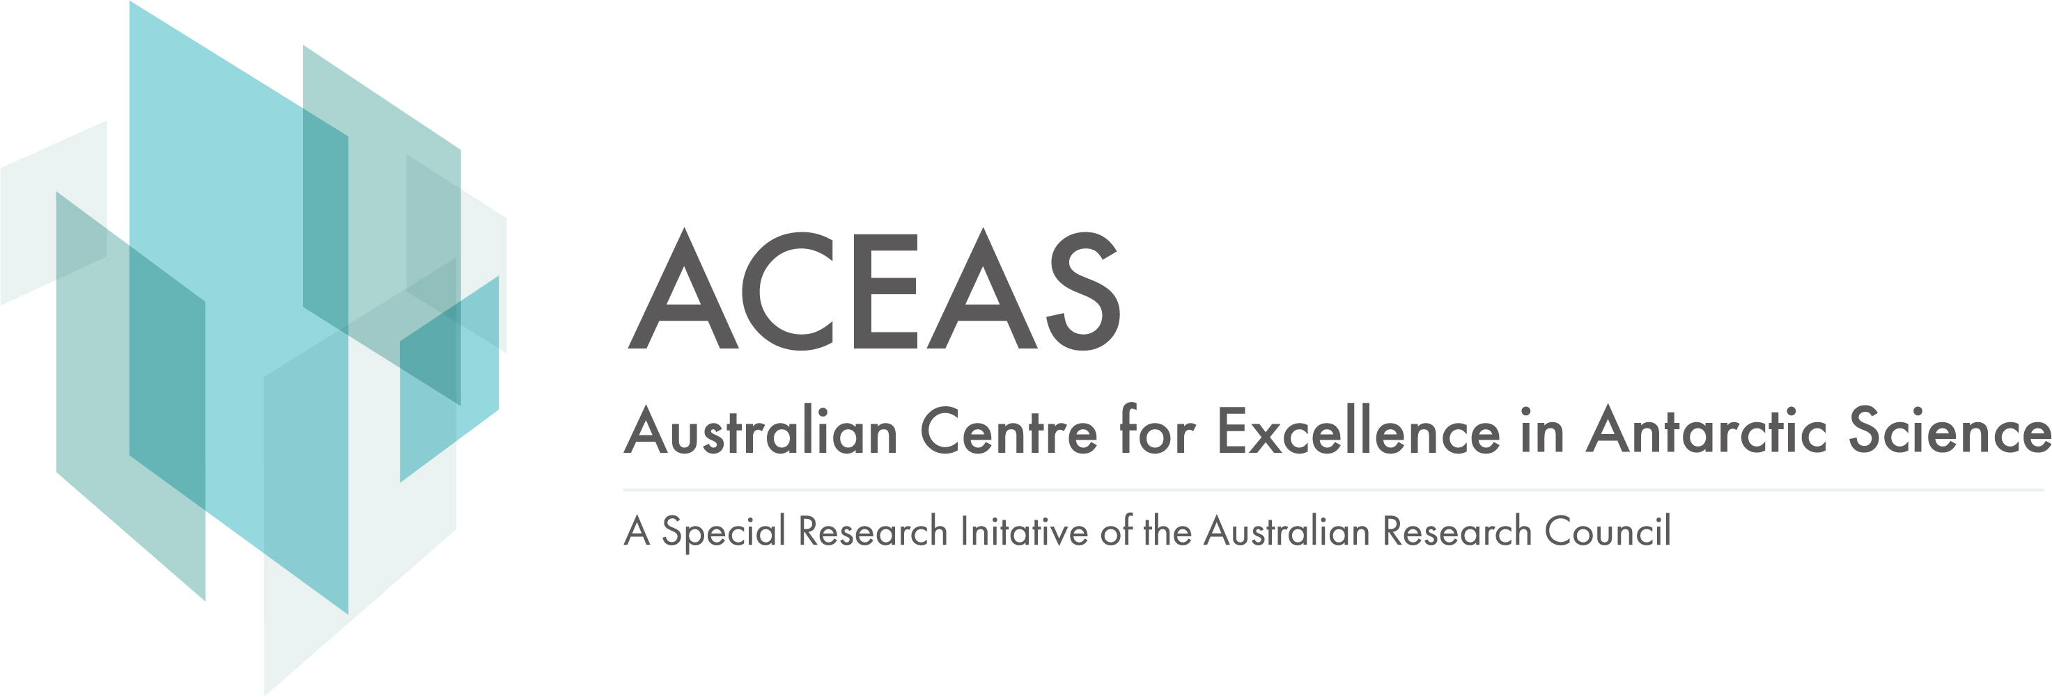

ARC Centre for Excellence in Antarctic Science (ACEAS)
Visiting Fellowships Application Form
Date Written: | September 2021 | Latest Revision: | February 2025

Nominee’s Details
Title: | Given Names:
Family Name:
Postal Address:
Email Address
Name of Home Institution:
Current Position:
Type of Visa currently held/required for visit:
Details of proposed visit
Proposed Arrival Date
Proposed End Date
Duration of visit
Sponsoring organisation
Sponsoring Staff Member(s)
Administrative contact
Existing collaboration/connections between ACEAS and the nominee (please provide details)

Other organisations/Universities the nominee will visit during this proposed visit (please provide details)
Proposed Program if Work/Intended Outcomes (dot points sufficient)
Budget
Personal contribution (by visitor)
Organisational Unit/Universities Contribution (i.e ACEAS, UTAS Visiting program, ANU, UNSW and other co-funding organisations)
Total funding request
Projected Expenditure
Airfares
Accommodation
Living Allowance
Other sundry Items (transport etc.)
Total Projected Expenditure
Approvals
ACEAS Node leader | Name:  Date:

Please submit the completed form to the ACEAS Project Officer ACEAS.project.office@utas.edu.au and we will seek approvals.

Antarctic.org.au

