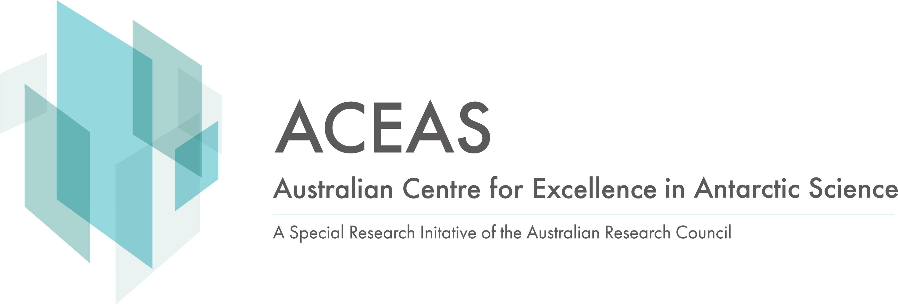
ACEAS Affiliated Investigator

ARC Centre for Excellence in Antarctic Science (ACEAS)
Affiliated Investigators Application Form
Date Written: | January 2022 | Latest Revision: | January 2024

Nominee’s Details
Title: | Given Names:
Family Name:
Postal Address:
Email Address:
Name of Home Organisation:
Current Position:
Research web page:
ORCID and Scopus IDs
Documents Checklist: (Please tick)
CV
Research Statement describing contribution to ACEAS programs (1 page; refer to revised ACEAS research proposal)

Program/s linked to:
P1 Circum-Antarctic and East Antarctic
P2 Regional East Antarctic and its Provinces
P3 Sub-regional and Regional Antarctic Margin
Other contribution to ACEAS as pre-discussed with the Director
Approval
ACEAS Director | Name:  Signature Date:

Please send the form to the relevant program leader their consideration and endorsement.

P1 – Anya Reading (UTAS), Alex Sen Gupta (UNSW), David Antoine (Curtin University)
P2 – Philip Boyd (UTAS), Laurie Menviel (UNSW), Nicole Hill (UTAS)
P3 – Adele Morrison (ANU), Kaihe Yamazaki (UTAS), Duanne White (UCanberra)

Please submit the completed form and Program leader endorsement to the ACEAS Project Officer ACEAS.Project.Office@utas.edu.au for processing.

