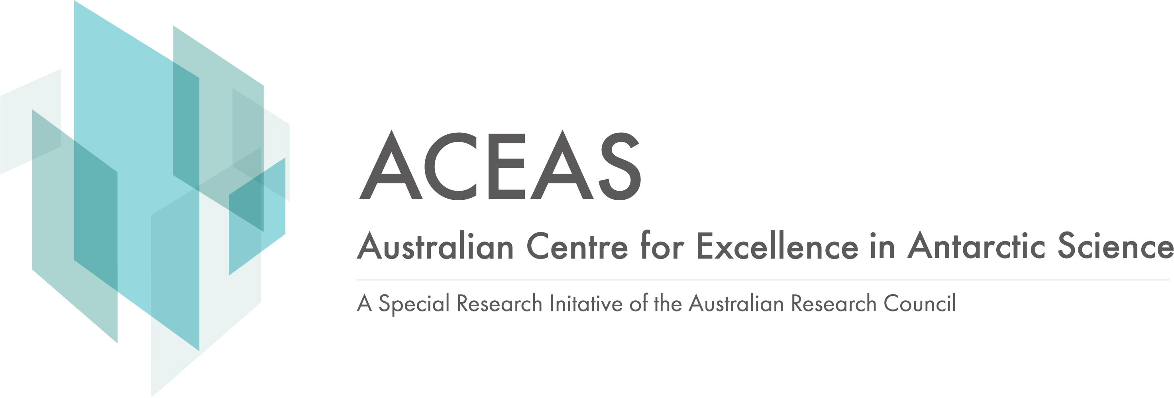

ACEAS Affiliated PhD Student

ARC Centre for Excellence in Antarctic Science (ACEAS)
ACEAS PhD Affiliation Form
Date Written: | January 2022 | Latest Revision: | January 2024

Student Details
Title: | Given Names:
Family Name:
Email Address:
University:
Documents Checklist: (Please tick)
CV
Brief statement by the supervisor on how the PhD project will contribute to ACEAS program(s) (0.5 page max; refer to revised ACEAS research proposal)

Program/s linked to:
P1 Circum-Antarctic and East Antarctic
P2 Regional East Antarctic and its provinces
P3 Sub-regional and Regional Antarctic Margin

Please send the form to the relevant program leader for their consideration and endorsement.

P1 – Anya Reading (UTAS), Alex Sen Gupta (UNSW), David Antoine (Curtin University)
P2 – Philip Boyd (UTAS), Laurie Menviel (UNSW), Nicole Hill (UTAS)
P3 – Adele Morrison (ANU), Kaihe Yamazaki (UTAS), Duanne White (UCanberra)

Program Leaders please consider and either iterate with supervisor or send the form with an email endorsement to ACEAS Project Officer: ACEAS.Project.Office@utas.edu.au

